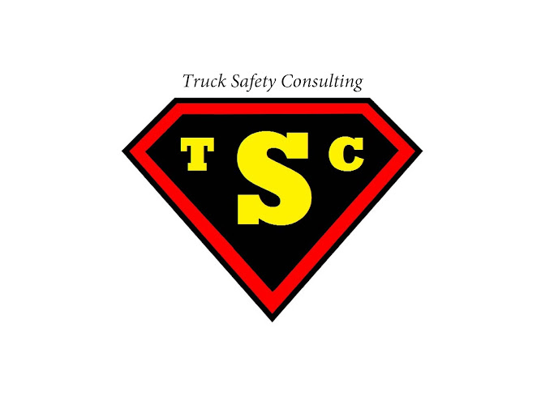
Truck Safety Consulting

PRESENTS

BEDFORD TWP. VETERANS CENTER’S
9TH Annual Golf Outing
Saturday, June 20, 2026
Giant Oak Golf Club

OUTING INFORMATION
Location: Giant Oak Golf Club, 1024 Valetta Dr., Temperance, MI
Time: 7:00 a.m. - Check-in
8:00 a.m. – Shot Gun Start
Hotdog at the turn
12:30 p.m. – Lunch (Steak, Baked Potato and Salad)
1:00 p.m. – Awards

Participation Fee: $100.00 per Player
Mulligans, Skins and Pins, On-course Games

Game Play: Shot Gun Start – Best Ball Score Scrambles
Hole-in-One $10,000 Hole-in-One Payout
Contest: (Rules Apply – Posted at the Hole-in-One Tee Box)

Awards: Longest Drive – Male and Female Winners: $50.00
Closest to the Pin – Male and Female Winners: $50.00

First Place Team: BTVC 9th Annual Golf Outing Winners Shirts
One Free-Round Golf Pass for Each Winner

Same Course – Same Food – Same Great Cause – Helping Veterans!

